Zhang XiaoLong -- PM c3416407



I am Zhang XiaoLong, a student at the University of Newcastle in Australia, majoring in Information Technology. During my time at the University of Newcastle, I gained practical experience and honed my skills in programming languages such as Python and C#, alongside my proficiency in SQL for data management. I have led diverse teams as a project manager in academic and extracurricular projects, where I improved workflows and efficiency. I have a strong background in economics from my previous studies in Shanghai, enhancing my analytical and problem-solving abilities. I am eager to advance my technical and managerial skills in a challenging and dynamic environment.

窗体顶端

窗体底端

Fang Yinglin c3416411

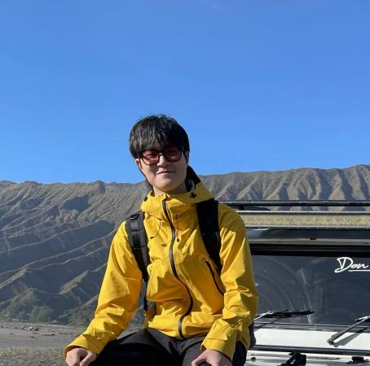  
I am Fang Yinglin, a student at the University of Newcastle in Australia, majoring in Information Technology. My skills include application programming, web development, system design, and knowledge of business intelligence and decision-making. I have applied these skills in various coursework projects, particularly in web programming and system analysis and design. I contributed to the creation of the new student website, focusing on designing the homepage and event pages. I value teamwork and completed the project with a responsible attitude. You can reach me at c3416411@uon.edu.au. I look forward to participating in more challenging web development projects in the future.  
  
Pan Jinke C3416405



Hello, my name is Pan Jinke, I’m Chinese. I enjoy traveling. I have been to the Maldives, Japan and Malaysia. I believe that traveling allows me to connect with more people and cultures, expanding my horizons. My major is information of technology, so, I can use some computer languages and tools such as python, C#. In this project, I actively communicate and exchange ideas with members, and apply all the knowledge learned in previous courses to it. I hope to create a website that satisfies new students and is practical. My email is C3416405@uon.edu.au If you encounter any problems with the website, you can contact me through this email.